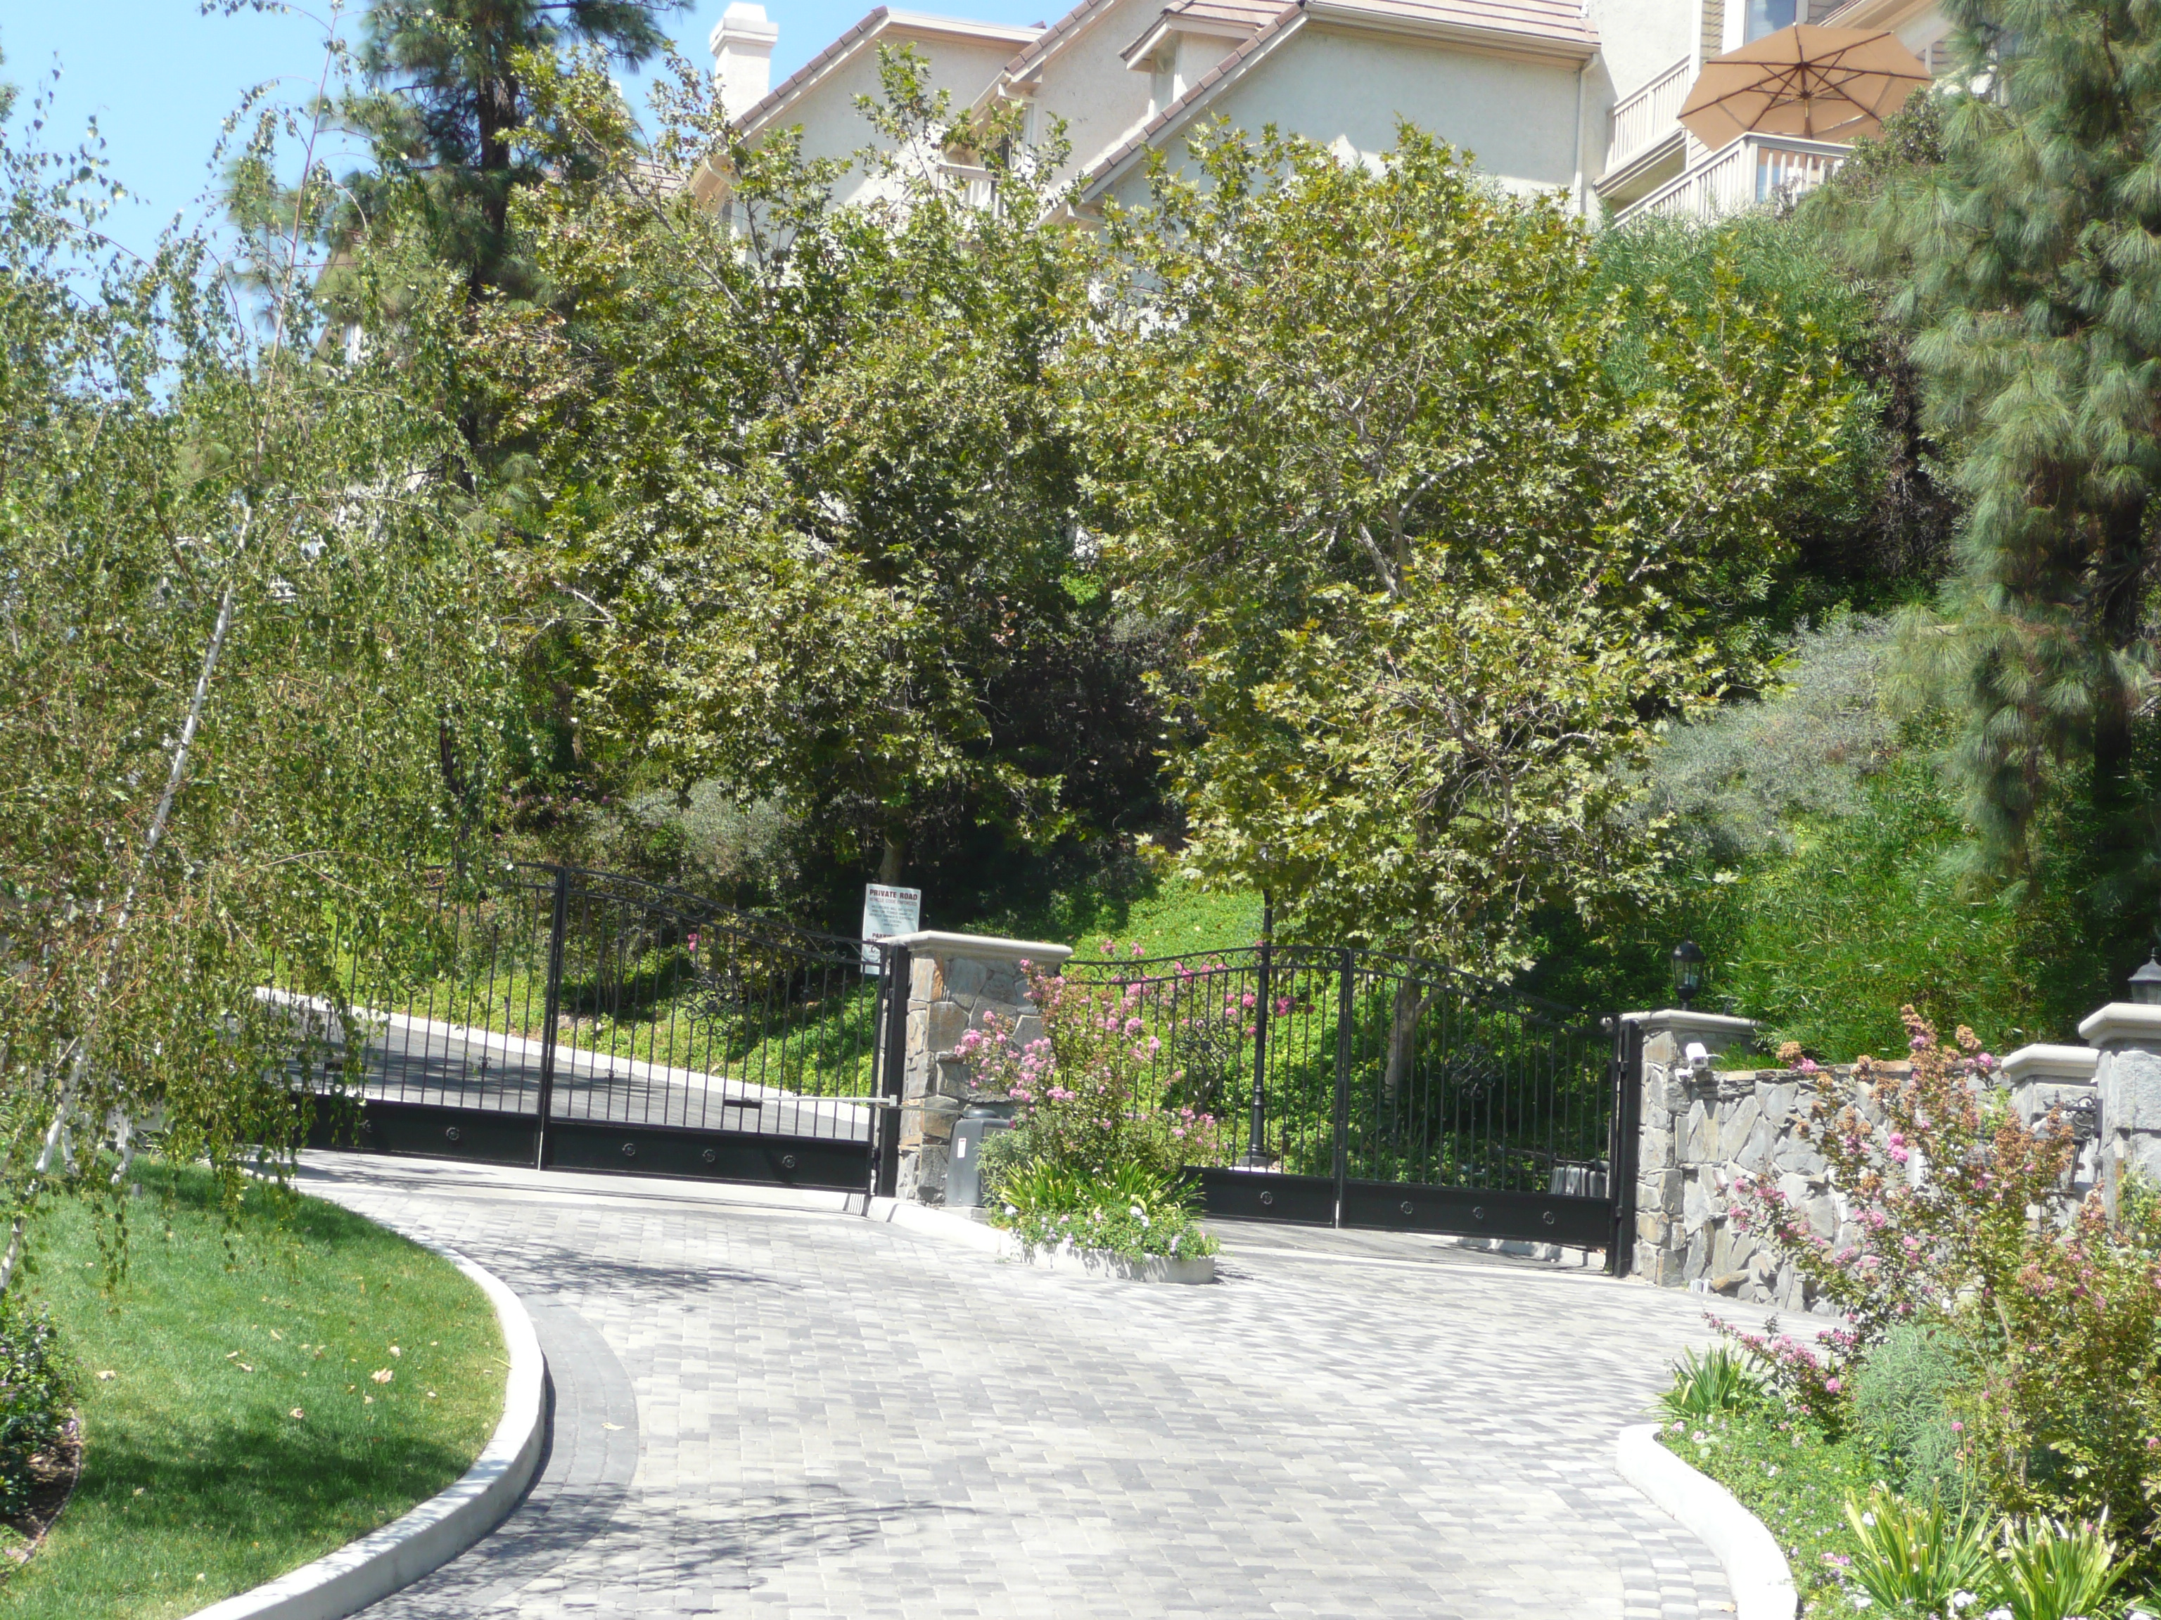
November 2007
WESTLAKE POINTE HOMEOWNERS ASSOCIATION RULES AND REGULATIONS

Westlake Pointe Homeowners Association, Inc. is managed by a Board of Directors. They are elected for a year’s term at the Annual Meeting usually held on the third Tuesday in March. The board is responsible for conducting business transactions and formulating polices in accordance with the Covenants Conditions and Restrictions (C C & Rs), and handling all affairs of the Association within the scope of these polices throughout the year. In addition the board of directors acts in good faith for the peace, health, comfort, safety and general welfare of the owners. The following rules have been adopted by the Board of Directors of Westlake Lake Pointe Homeowners Association, Inc. and have taken effect as Association rules. The rules are established under the Declaration of Covenants, Conditions and Restrictions for Westlake Pointe Homeowners Association, Inc., Section 3.07 (a). In the event of any material conflict between county or city ordinances or California Vehicle Codes they will prevail over any association rule.
Table of Contents

General ………………………………………3

Streets, Vehicles, Parking ………………..5

Pets …………………………………………..7

Pool Area and Spa …………………...…...8

Monthly Assessments ………………….10

Architectural Rules ………………….…..11

Directory ……………………………….….13

GENERAL

- Each unit shall be occupied as a single-family residence.
- No business occupation, trade, or other non-residential pursuits shall be conducted in any residence or garage.
- Each owner/occupant is responsible for maintaining the interior of their residence in good condition and repair, including window coverings visible from the exterior which must be of neutral color.
- No signs of any type shall be displayed at any residence or in the common areas except one sign advertising the residence for sale or lease and one sign posted close to the residence indicating the presence of a security system or patrol. Real estate signs are limited to 18” x 24”.
- The maintenance and landscaping of individual entry areas is the responsibility of the homeowner. This area is defined as within the gated courtyard. Light fixtures and bulb replacement in this area are the responsibility of the homeowner.
- No personal art objects, such as statuary, decorative, or antique items, etc., may be placed outside the courtyard.
- No antennas/aerials, except small satellite dish antennas, may be installed on the exterior of any residence. The location and design of the dish antenna must be approved by the Architectural Committee in advance of the installation.
- Clothing, towels, or other articles are not to be hung or draped over patio ledges or entry gates. Clotheslines/racks are not permitted on patios or in front entrance.
- Rubbish must be placed in appropriate covered containers and put out no more than 24 hours before weekly collection. Any spillage from containers after collection is to be cleaned up in a prompt manner. Containers and covers should be returned to the garage as soon as possible but no more than 24 hours after pick-up. Containers must be kept inside garages.
- Dangerous weapons, including BB guns, may not be carried in any part of the complex. Violations will be reported to the legal authorities.
- Garage sales are not permitted except by special ruling of the board.
- All infractions of the Rules and Regulations are subject to fines.
- Board members are responsible for maintaining the common area, and are the only ones who can make adjustments to equipment or have them made through the management company.
- Owners of rental units must supply Rules and Regulations to tenants, as owners are liable for acts of tenants and will be fined for violations.

STREETS, VEHICLES, PARKING
Westlake Pointe’s streets, lighting, landscaping, and storm drain systems are privately owned, maintained, and repaired by the Association.
The speed limit is 15 m.p.h.
- Parking in front of garages and along red curbsides or specifically restricted signed areas is prohibited due to fire regulations and potential liability to the Association. Illegal parking is subject to fines or tow-away at the owner’s expense.
- Residents’ vehicles must be kept in garages and the garage door must be kept closed when not in use. Garages may not be converted for purposes other than the parking of automobiles. Any resident with more than two cars may use the designated “guest parking” spaces. A 30-day move-in transition will be allowed but garages must be made available for vehicles after that period.
- Storage of inoperative vehicles in guest parking areas is prohibited. Violators are subject to tow at their expense.
- Automobiles shall be parked in designated parking places only within the single car markings. No vehicle shall be parked in a manner that impedes ready access to another resident’s garage.
- Residents may not park commercial or recreational vehicles, campers, trailers, boats or similar vehicular equipment on the streets, driveways, or guest parking areas within Westlake Ponte. Temporary dumpsters and their location must be approved in advance by the Architectural Committee. They must be placed on proper supports, such as plywood, to prevent damage to the street surface. Any damage caused by a dumpster is the responsibility of the home owner.
- Mechanical/repair work on any vehicle is not permitted in the streets, driveways, or parking areas unless of a short term emergency nature.
- Homeowners are responsible for maintaining garage doors in proper working order including appropriate conforming hardware replacement.
- Scootering, skateboarding, and roller-skating or roller-blading are prohibited on the streets within Westlake Pointe in view of the potential liability to the Association and the concern for the safety of all residents and guests.
- “Playing” in the streets is not permitted due to the streets being the official vehicular path.
- All repair and maintenance of the home interior and exterior is the responsibility of the individual homeowner.
PETS
- County and city ordinances pertaining to pets apply to this complex (including licenses, etc.).
- Only a reasonable number of pets, as defined by county/city ordinances, will be allowed per residence.
- Pets must be kept on a leash and in the control of the person holding said leash when outside the boundaries of the residence.
- Owners of pets must pick up/clean up any excrement from the pet left anywhere in the complex.
- Owners will prevent their pets from making excessive noise, i.e. barking, or be a nuisance to residents of the complex.
- Pets are prohibited in the pool area.

POOL AREA AND SPA
The pool is heated from April 1 through November 1. The spa is heated throughout the year.
- Pool hours for all residents and guests are: 8 a.m. to 10 p.m. daily.
- Because the pool is not supervised, each owner/resident assumes full responsibility and liability for controlling the conduct of family members and guests. The pool area is for owners, residents and accompanied guests only.
- Insurance restrictions and the county health code require the gate to the pool area to be kept closed and locked at all times. Failure to comply could result in your own personal liability. Additional or replacement keys may be purchased through the management company.
- Homeowners and residents have first priority on pool use. Guests must be accompanied by a resident and the number of guests is limited to four per residence at one time.
- Customary and usual swimwear is to be worn while in the pool or spa. Cut-offs, jeans, etc. are not permitted.
- Pool area patio furniture, supplied by the Association is not to be abused or removed from the area. Personal patio furniture is prohibited in the pool area.
- Children under the age of 14 must be accompanied by an adult 18 years of age or older. Children under the age of 12 are not permitted in the spa unless a parent is in the spa at the same time. Children under the age of 5 are not allowed in the spa at any time. Children of “diaper age” must wear rubber pants while in the pool.
- Towels must be placed over pool furniture when using suntan oils and lotions.
- Glass containers, bicycles, loud amplified music (tapes/radios/etc.) are prohibited in the pool area. Please do not litter.
- No toys, paddle boards, sport equipment, etc. are permitted in the pool. These items can mark or damage the pool plaster.
- Running, “horseplay”, “rough play,” and excessive noise, whether from individual voices or audio equipment is prohibited.
- Intoxicated individuals are not allowed in the pool/spa area.
- Life preservers, poles and safety equipment are for emergency use only and must be left in the pool area.
- Pets are prohibited in the pool area.
- Smoking is prohibited in the pool area.

WARNING:
Children should not submerge their heads/bodies in the spa – serious injury and possible death could be the result.
MONTHLY ASSESSMENTS

- Common area expenses are divided equally among the 64 units. Monthly assessments may be increased or decreased, according to Civil Code 1366, by the Board of Directors to meet the financial needs of the association. Special assessments may also be levied, per Civil Code 1366, to meet the financial needs of the association.
- Regular assessments are due monthly. Payments are due the first of the month. Payments not received within 15 days of the stated due date are delinquent.
- Late charges will be imposed on delinquent assessments in the amounts permitted by the CC& R's, the association's collection policy, and the Civil Code. The association may bring legal action for payment of delinquent assessments and recover not only the delinquent assessments, but also late fees, interest and collection costs incurred by the association.
- Unpaid assessments may become liens against the property and may be foreclosed upon by the Association for failure to pay.
ARCHITECTURAL RULES

The C.C.& Rs. direct that the maintenance for each home is the sole responsibility of the homeowner , but the Architectural Committee of the Board of Directors sets the standards for the visible exteriors. If a homeowner wishes to alter part of the visible exterior, an application form, supplied by Management, must be filled out and submitted for approval. Plans and neighbors comments may be necessary. Management will provide a list of approved paint colors. No work is to begin until Board approval is obtained.
External repairs that do not change the external appearance, including heat pumps, roofs and decks, only require a report to Management describing the repair and timing so that we are aware of the appearance of contractor’s vehicles. If you have any question as to whether or not an application is necessary, take no action until advised by Management.
Most items outside your gate and walls are common area that is solely the responsibility of the HOA. The walk from front door to driveway passes through the gate into the common area. Any change beyond the gate requires an application. Other than this, no owner can make an alteration, addition or modification to any portion of the common area.
The Architectural Committee will respond as quickly as possible to homeowner requests for approval. Approval of any proposed work must be in writing. If the Architectural Committee fails to respond to a homeowner’s request within 30 days, either by approval, disapproval, or request for additional information or modifications, the request shall be deemed approved.

The Architectural Committee only approves or rejects submissions in keeping with aesthetic integrity of Westlake Pointe and is not responsible or liable for any issues relating to current building codes.

Homeowners are responsible for obtaining all appropriate permits from the City of Westlake Village but obtaining such permits does not necessarily mean approval by the Architectural Committee.

When work is completed, the homeowner must notify the Architectural Committee for inspection. The Architectural Committee has the right to rescind its approval if the work is not done in accordance with the documentation submitted and approved.

Contractors or anyone doing any type of construction or using power tools is limited to Monday through Friday, 8 a.m. to 6 p.m., Saturday, 8:00 a.m. to 5:00 p.m., and is not permitted on Sunday, New Years Day, Memorial Day, July 4th, Labor Day, Thanksgiving and Christmas.
The complex must be clean and neat at all times and construction trash and debris must be removed from the site on a regular basis (no less than once per week) at the owner’s sole cost and expense. Dumpsters must first be approved by the Architectural Committee and must be placed as close as possible to the owner’s driveway, but not blocking the fire lane. Proper support, such as plywood, must be placed under the wheels of the dumpster to prevent damage to the road surface. In the event of damage to the pavement, the owner shall be responsible for the cost of all repairs.

Neither the Architectural Committee nor the Association or its officers shall be liable for any damage, loss or prejudice suffered or claimed on the account of the approval or disapproval of any plans, drawings and specifications, or the construction or performance of any work, whether or not pursuant to approved plans, drawings and specifications.

DIRECTORY

EMERGENCY: Dial 911

TO REPORT ANY CONCERNS REGARDING THE COMPLEX, PLEASE CALL THE MANAGEMENT COMPANY.
Spectrum Office: 805-642-6160
Spectrum emergency: 805-535-5222
Sheriff: 818-878-1808
Fire Dept: 818-889-1626
Front gate access for guest call in from the gate telephone: press 9 on your telephone.

Weekly garbage pick up: Wednesday, or Thursday following a holiday.

